**Mentoring at Work: How (and Why) to Implement It in Your Organization**



“We tried mentoring once, but it never really worked. Anyway, people find their own mentors informally. What I need to know is how to fill my leadership pipeline.”

This is a common refrain we hear from senior HR leaders. Yet, our research on high-potential leaders shows that**mentoring in organizations is ideal for helping to retain top talent and build a leadership pipeline.**

Many high-performing organizations consider mentoring a key competency among their leaders — and leaders who take mentoring seriously and handle it effectively have a profound impact.

Whether it’s a formal or informal arrangement, mentoring at work benefits everyone involved: the mentor, the mentee, and the organization that supports it. Effective mentors develop the leadership capacity of their mentees, while increasing their own skills. They nurture the alignment between employee aspirations and organizational imperatives, and they create depth and loyalty within their organizations. Plus, they transfer their knowledge and expertise back into their organizations.

Here are some of our research findings, insights, and recommendations on mentoring in organizations to help you structure an effective mentoring program.

**First, What Is Mentoring at Work?**

Our guidebook, *Seven Keys to Successful Mentoring*, defines **mentoring as an intentional, developmental relationship in which a more experienced and more knowledgeable person nurtures the professional and personal life of a less experienced, less knowledgeable person.**

Typically, a mentor has been in an organization or profession longer and has greater authority within the organization or profession than does a mentee. The combination of expertise and position enables a mentor to have significant impact on a mentee. (We say “typically” because reverse mentoring arrangements flip this model, and can also be highly beneficial.)

Mentoring at work can motivate individuals to learn and grow, expose them to learning opportunities, and provide support for the learning and growth. In many cases such relationships are mutually developmental, for mentor and mentee alike.

**Who Benefits From Mentoring in Organizations?**

**Organizations benefit greatly from mentoring programs.** Mentoring at work helps businesses attract and retain talent, and enhance organizational commitment among employees who seek developmental opportunities. Turnover decreases, and development accelerates. Typically, mentors have a well-developed view of organizational direction and dynamics, which they impart to mentees, and can better align a mentee’s efforts with organizational objectives, enhancing organizational capacity.

**The people who are mentored benefit in numerous ways:** gaining access to leadership opportunities, career mobility, better rewards and higher compensation, increased adaptability when facing new situations, improved professional identity, greater professional competence, increased career satisfaction, greater acceptance within their organizations, and decreased job stress and role conflict. Additionally, mentees enjoy some of the credibility and influence of the mentor through association.

**And mentors themselves benefit as well.** Many studies have shown that mentors are more satisfied with their jobs and more committed to their organizations than those who are not mentors. And research has found that leaders judged as effective mentors by their direct reports had higher performance ratings from their bosses.

In short, great leaders need to be mentored. And great leaders need to mentor.

**Mentoring Programs and Leadership Development**

**Mentoring at Work Is Key for First-Time Managers**

When individual contributors or professionals are promoted into their first formal leadership positions, many do not expect the transition to be as difficult as it is. But moving into a role of leading others is an identity shift, and many first-time managers aren’t prepared. Worse, they often lack the support and development needed to help make that transition successfully.

Yet when new managers are not supported through this transition, they suffer personally — and so do their teams and direct reports. By extension, this affects the organization’s leadership pipeline, which ultimately can negatively impact the bottom line.

Given the important role that first-time managers play in talent development and succession management, organizations should help ease their transition by providing them with access to leadership development — especially courses targeted to the needs of new managers — and by exploring formal organizational mentoring programs to support them. For more recommendations, read our white paper on proven strategies HR leaders can use for mentoring first-time managers.

**Mentoring Helps Experienced Staff, Too**

Mentoring can also provide an excellent opportunity for more experienced staff who want to become managers. One of the biggest skill gaps that many managers have is the ability to coach, develop, and mentor their own direct reports. While developing employees is important for managers to do, many aren’t as strong at it as they need to be.

By serving as mentors, managers help mentees while also improving their own performance and satisfaction and gaining essential management skills. In fact, based on our work with the Leaders’ Counsel, we’ve found that those who mentor and advocate for others:

* Are perceived by others as more effective leaders;
* Have a stronger commitment to their organizations;
* Enjoy a greater sense of well-being, including increased job and personal satisfaction; and
* Strengthen their personal networks and get quicker access to job-related and organizational news.

**Coaching vs. Mentoring in Organizations: What’s the Difference?**

Coaching and mentoring at work are related but different roles — even though they sometimes overlap and may be performed by the same leader. It’s important for both the mentor and mentee to understand these distinctions.

**While coaching typically focuses on *enhancing current job performance*, mentoring focuses on *career path*.** Coaching tends to focus on helping someone resolve a here-and-now issue or blockage for themselves. Mentoring, on the other hand, focuses on helping the mentee become more capable in the near future. This gives the mentor time to guide and advise the mentee on issues that will arise, but may not have yet.

Sometimes, mentors will play the role of a coach when they don’t have the luxury of time to fully prepare their mentees for the future; they have to help them perform *now*. Mentors can hold coaching conversations to guide a mentee, helping to motivate and inspire by relying heavily on questioning and listening skills.

Mentors can also leverage their positions to sponsor mentees for developmental experiences and to survey the environment for threatening forces and opportunities. They can leverage their expertise to transfer knowledge and help expand networks.

**Mentoring in Organizations Can Build Stronger, More Inclusive Cultures**

Research shows that diverse teams drive better business performance, and organizations with greater diversity become more resilient and innovative. Ideally, leaders in positions of power would mentor and sponsor talent — regardless of gender, race, or other social identities.

But because many aren’t doing this, their leadership pipeline suffers and their organization loses out on the potential of its talented leaders — often and especially those who are women and people of colour. These leaders in particular need a network of champions, and organizational mentorship and sponsorship programs can be a step toward building a stronger and more diverse leadership pipeline.

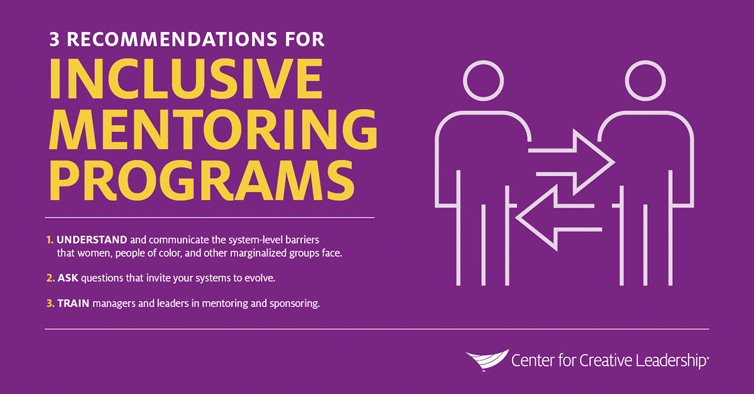

**3 Recommendations for HR Leaders Crafting Mentoring Programs in Organizations**

Even without a formal organizational mentoring program in place, talent management professionals can still attract and retain more talent by:

* building mentoring and sponsoring into leadership development efforts and on-boarding processes;
* creating formal programs to pair high-potentials with specific mentors and sponsors; and
* encouraging a culture where mentoring and sponsorship of talent is expected.

The key for successful formalized programs around mentoring in organizations is to set clear roles and responsibilities, and to have clear objectives for establishing coaching and/or mentoring arrangements. To make those things happen, consider these 3 recommendations.

1. **Understand and communicate the system-level barriers that women, people of colour, and other marginalized groups face.** How can you help senior leaders understand what practices, procedures, norms, or behaviours might be seen as supportive or dismissive of talented people who are in minority or marginalized groups? Can you increase inclusive leadership practices across the organization?
2. **Ask questions that invite your systems to evolve.** Challenge assumptions when you hear them, and try to open up possibilities for different styles and skillsets. Ask what might be overlooked as you fill positions: *“Here’s the profile of the last person in this job…but what abilities might we need now?”*
3. **Train managers and leaders in mentoring and sponsoring.** Don’t assume senior leaders are clear about their role in helping other leaders, or that they know how to have developmental conversations, particularly with a mentee or sponsoree. If senior leaders are “expected” to mentor and sponsor more junior high-potentials, ensure these expectations are explicit and transparent — for example, included in the talent management, succession planning, or performance review processes. Prepare executives for the unexpected by providing them with guidance, tools, leadership development, and support to build their coaching skills.

There are lots of ways to structure mentoring in organizations. It can be an HR or organizational initiative, with formal structuring, monitoring, and organizationally aligned goals, or it can be a more informal process developed by the parties involved.

Whatever shape your mentoring program takes, remember that the most successful mentoring programs include careful, strategic planning. Use these resources to develop your mentoring program and see the results of improved engagement, retention, and overall performance.

April 20, 2021

Leading Effectively Staff

[Mentoring at Work: How to Implement in Your Organization | CCL](https://www.ccl.org/articles/leading-effectively-articles/mentoring-at-work-how-and-why-to-make-it-work-for-your-organization/)